Collaborative teaching and learning tools

accessibility features

learning reward system

gamified learning


Links to other pages
Title

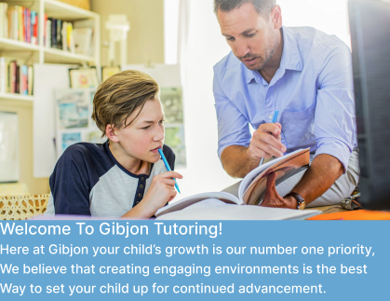
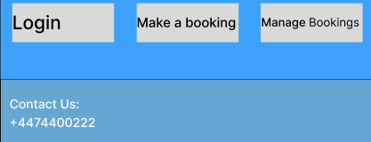
Added a topbox image and some text to interest user and show them what the values of the website are
Added large buttons with links to other pages for people who may have difficulty seeing the other links

Added contact number for flavour

